Example No 1:

Write a Program to Take input From User If A==0 Then Terminate

Solution:

in

sto 95

lda 95

brz 08

brp 06

hlt

out

br 00

hlt

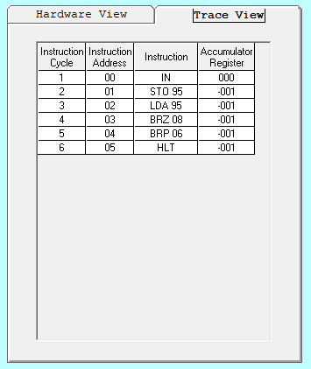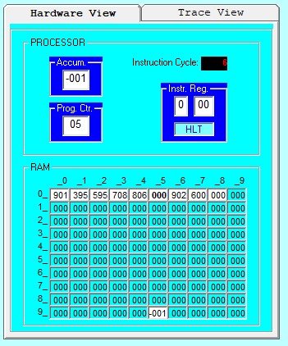Output:

Example No 2:

If a<10 the Print (a+a) Else terminate

Solution:

in

sto 95

lda 95

sub 99

brp 09

lda 95

add 95

out

br 00

hlt

\*99

dat 010

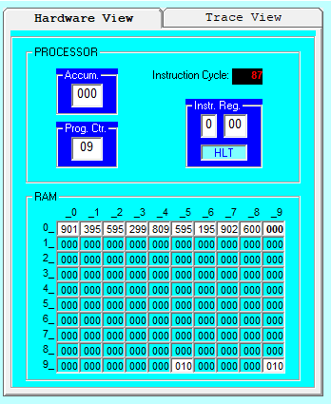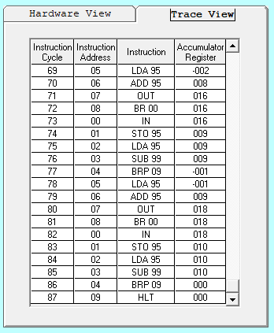Output:

Lab Task No 1:

Write a program to print the square of any integer in the range 1-31.

Solution:

in

sto 95

lda 98

add 95

sto 98

lda 97

add 96

sto 97

sub 95

brz 11

br 02

lda 98

out

hlt

\*96

dat 001

dat 000

dat 000

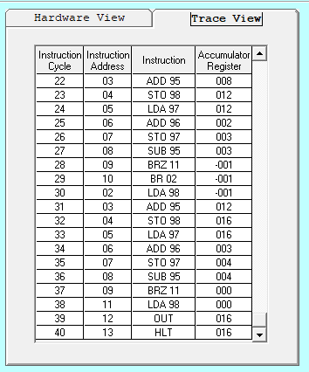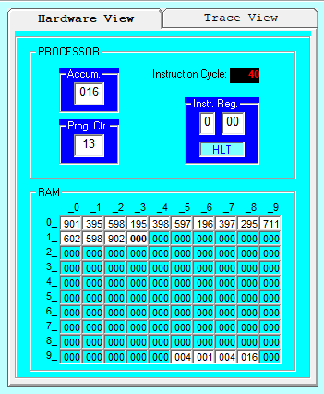 Output:

Lab Task No 2:

Write a VVM program which take an integer input and display table of that integer.

Solution:

in

sto 95

lda 98

add 95

sto 98

out

lda 97

add 96

sto 97

sub 90

brz 13

br 02

hlt

\*90

dat 010

\*96

dat 001

dat 000

dat 000

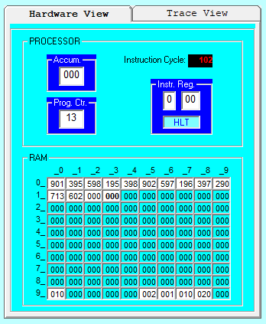 Output: